Day 7: (task 7)
Aim: Creating Views
1. Creating a Simple View from a Single Table:
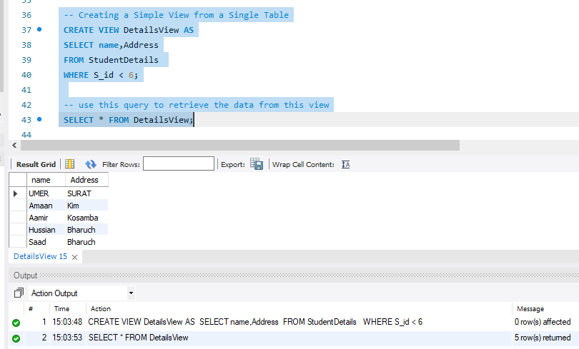
2. Create a view named Details Names from the table Student Details:
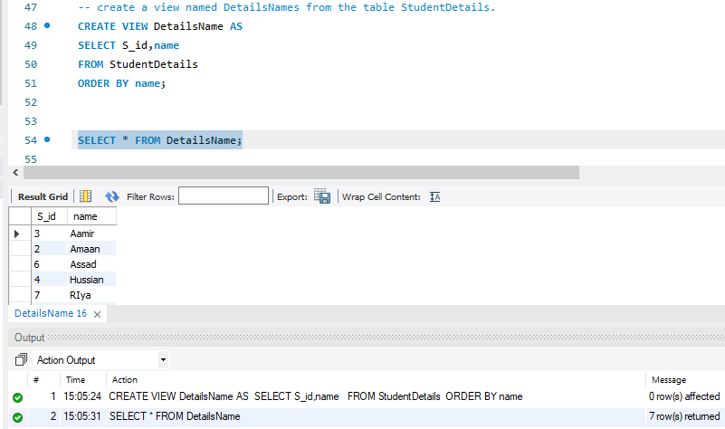

3. Creating a View from Multiple Tables:
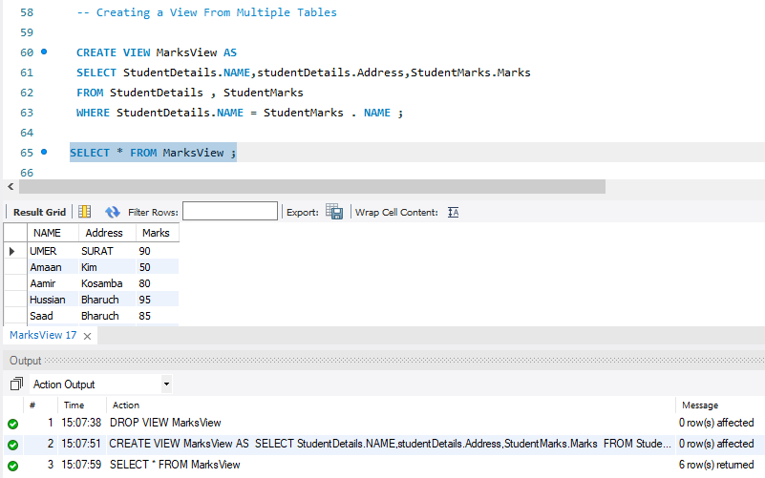
4. Listing all Views in a Database:
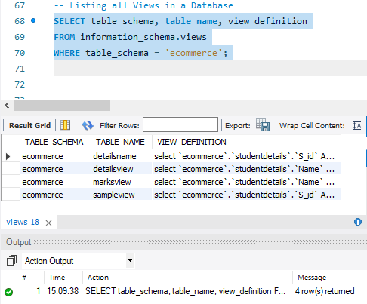
5. Deleting a View:
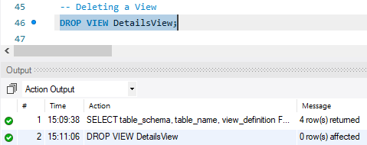
6. Updating Data through Views:
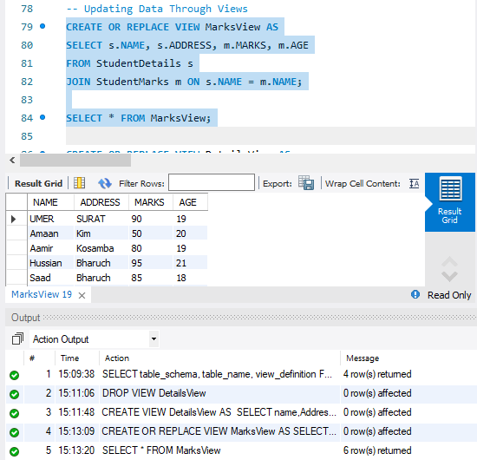
7. WITH CHECK OPTION Clause, Insert ,Display The Data:
